Criminal Exploitation Screening Tool – for practitioners
The criminal exploitation of children is a type of child abuse where children are often manipulated, coerced or forced into criminal activities. They may believe they are making choices or being rewarded but they are being harmed and used by others. The criminal exploitation of children can be hard to spot, indicators may overlap with other forms of exploitation, mimic typical developmental behaviours, or simply is not readily visible. That is why it is important to be curious about what is happening in a child’s life and look at the bigger picture.
This tool helps you think about the risks and signs of exploitation in a structured way. It’s not a checklist or a scoring system. Instead, it supports your professional judgement by helping you explore all the relevant information and how things are connected.
No child can agree to being exploited. Even if they seem to be gaining something or are involved in crime, they are still victims who need protection and support. This tool always uses the word 'child' to remind us that anyone under 18 is still a child first.
The tool is meant to support your local child protection processes, not replace them. It encourages you to use child-centred, rights-based, and trauma-informed approaches that keep the child’s safety and wellbeing at the heart of your decision-making.
It’s important to record clear information, including names, places, and what has happened. This helps build a fuller picture of what the child is experiencing, track changes over time, and plan better support. It can also help identify those who are exploiting children and support wider disruption and safeguarding work.
This tool is based on the principles of contextual safeguarding and FRAME guidance. These help us look at risk not just in individuals, but in the places
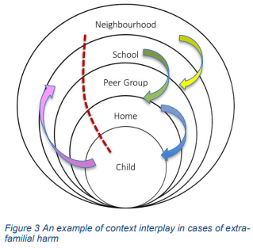
and relationships around them. We want to build on strengths, reduce harm, and create safer spaces for children and young people.
Firmin, C., Hill, T., Hill, W., Turnell, A., Turnell, P., & Walker, J. (2021). Signs of Safety and Contextual Safeguarding Key Messages for Practice. https://www.contextualsafeguarding.org.uk/media/tugcd4ki/key_messages_briefing_final_-cs_and_sos.pdf
‌Using This Tool
This tool is not exhaustive but includes a range of potential indicators that could be a sign that a child is being criminally exploited. These include -behaviours, situations, and life experiences that have been observed in many children at risk of or being exploited and other risks of harm. It is not a checklist that covers everything, and it is important to hold in mind that not every child will show the same signs.
Use this tool alongside your local assessments like, Signs of Safety, START-AV or the My World assessment. It’s mainly for children under 18, but it might also be helpful for young adults in some situations.
You might see one clear sign of concern, or you might notice lots of small signs that add up. Some things might seem minor alone, but together they can point to serious harm. Children can be affected in many ways – including harm to themselves or others. That’s why it’s important to look at the whole picture and how different parts of a child’s life connect. As you work through the tool, keep in mind:
- Any child no matter their gender or background can be exploited.
- Children may face more than one type of exploitation at once (e.g. criminal and sexual).
- Exploited children may harm others, a child protection approach is still needed to ensure protection for them as well as others.
- Children might be asked to do small tasks that don’t seem linked to crime at first.
- Their behaviour might be shaped by trauma, fear, or pressure from others or need to be included. Understanding the underlying needs will guide appropriate interventions.
- Taking part in criminal activities does not mean they are not being exploited.
- Times of change, such as moving schools or family disruptions, are high-risk periods for exploitation.
- Children and young people often do not accept or realise they are being exploited.
- Not all signs of exploitation carry the same weight, and not all warning signs mean a child is being exploited but they should always prompt curiosity.
- Explaining why you think a sign/ indicator is relevant and or present is important and helps measure changes over time.
- Paying attention to new or unusual changes in behaviour is essential – they could be early signs something is wrong.
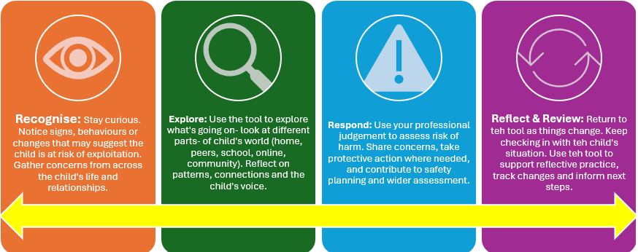
Process to follow:

Worker completing tool |  | Agency
Date of completion |  | Contact details: number/email

1. Lead Professional and Child Details
Child’s Name |  | Gender
Date of Birth |  | Address
Ethnicity

2. Summary of Concerns
Write a short summary of why you are worried about this child or young person. Include what has happened, who shared the information, when it happened, and any other details that help explain the concern.

3. Child’s Voice/ Perspective

What has the child shared about their experiences, worries or relationships?

What do they think about other people’s concerns about them?

Do they see any issues or risks for their wellbeing?

Can they tell you what helps them feel safe/ would make them feel safe?

4. Parents/ Carers Views/ Perspective

What are they worried about and why?

Have they noticed any recent changes in behaviour, mood, friendships, or routines?

Are they worried about anyone their child is spending time with (in person or online)?

What difficulties are they experiencing trying to keep their child safe?

Do they feel supported by services? What would help them right now?

Are there other stressors affecting the family (e.g. housing, finances, safety in the community)?

5. Screening Indicators
Important note on interpreting these indicators: These indicators are not exhaustive and should not be viewed in isolation. A single concern may raise important questions, but it is often the combination and interaction of multiple indicators that points to heightened risk of harm. Patterns across different areas of a child's life can suggest they may be experiencing significant harm, whether that harm is directed toward themselves or toward others.
This tool is designed to support a holistic understanding of the child’s lived experience. It encourages professionals to consider the full context — the environments the child moves through, the people they are connected to, and the relationships that shape their sense of safety, identity and belonging. It supports trauma-informed, developmentally sensitive decision-making across systems that must uphold both the child’s and the rights of others.

Description and Analysis of Concerns
Indicators/ Signs of Exploitation
The standard of proof for prosecution is high and is not a reliable indicator of a child’s actual behaviour or motivation.

Indicator | Yes/No | Comments / Evidence (include timescales) and relevance
5.1 Family/ Carer & Home Environment
Recent or existing family relationship breakdown that is affecting the child (may be between others in the family home)
Parent’s withdrawal from engagement or retracting information.
Financial pressures or housing issues that affect safety and stability.
Child’s family members or home being targeted E.g. family members assaulted (in same house as child/ yp or perhaps in prison estate), home attacked/ vandalised.
Parental/carer expresses concerns. Seems withdrawn / emotionally ‘switched off’ – from family.
Family involvement in offending; may include Serious Organised Crime (SOC).
The child is currently being looked after away from home or involved with services.
5.2 Emotional & Behavioural Changes (examples could be)
Observed changes in behaviour – increased aggression/violence/emotional outbursts/ withdrawal, or fearfulness.
Signs of fear, anxiety, or being constantly on edge (hypervigilance) (may be related to specific places and people or in general).
Difficulty sleeping or frequent sleep disturbance, which may be linked to worry, trauma, feeling unsafe or need to act when contacted.
Behaviour which may be rooted in fear, perceived need for safety or as a sense of identity and kudos such as accessing weapons; may be carrying or have them placed in the community.
May be avoiding time with family in the community or seeking proximity to family (to protect them or feel protected).
Professionals are unable to connect with the child and the child may be avoiding support – this may reflect fear, mistrust, previous harm or feeling unsafe with services.
5.3 Peer Influence & Exploiter Associations
Spending time with peers supportive of offending behaviour and/ or may also be involved with organised criminality, and/or also criminally exploited.
Pick up/drop off by unknown vehicles/ people, especially without any explanation.
Reports of being taken to parties, people’s houses, unknown areas, hotels, nightclubs, takeaways or out of area by unknown adults or other young people (also links with missing, locations and places concerns).
Involvement in recruiting peers (may indicate the child is being used to exploit others after being exploited themselves).
Unknown whereabouts or associations – secrecy about who they are with/areas they are going.
Information that the child is in contact with adults or peers in the prison estate, which may raise concerns if there is no known or safe reason for this.
5.4 Health & Wellbeing
Unexplained physical injuries. May be reluctant/unwilling to seek/receive medical treatment. Or to disclose any details how injuries were sustained.
Difficulty walking or sitting.
Signs of restraint, such as rope burns or handcuff marks.
Physical injuries without reasonable explanation.
Physical appearance suddenly changed (could also relate to sense of identity).
Found with drugs inside rectum or vagina.
Observed changes in emotional well-being.
Disclosure of sexual or physical assault, followed by withdrawal of the allegation.
Neglect.
Neurodivergence and what this means for their understanding, functioning, relationships, understanding of harmful situations.
Mental health concerns such as emotional distress, self-harm or suicidal thoughts.
Use of drugs or alcohol to cope, or introduced through peers/ older individuals
Concerns about how prescribed medication is accessed or used (may be own or others).
The child may feel trapped or under pressure due to money owed (e.g. drug debts or coercive situations they cannot exit safely).
5.5 Education & Daily Routine
Not attending school, missing from, or being excluded (frequency may be changing, may be short or longer periods of absence).
Increase in fixed term exclusions especially for physical and verbal abuse, sexually inappropriate or harmful behaviours.
Changes in peer group.
Drop in school performance or engagement without obvious reason.
Loss of interest in usual activities and hobbies; may be excluded from usual clubs.
Has there been a change to usual routine and activities?
5.6 Possessions/ Wealth/ Communication
Multiple mobiles/changing phones frequently and/or significant increase phone calls/texts/messages from unknown numbers which they are unwilling to explain or try to hide, pass off in some manner (secretive behaviour).
Increased wealth /possession of significant quantities of money that cannot be explained.
Possession of material goods out with financial means.
Found with access items (e.g. hotel key cards, unfamiliar property keys) that suggest they may be spending time in unknown or unsafe environments.
5.7 Online Activity
Online presence or withdrawal from online, posts, connections online, getting into trouble online (e.g. sexual behaviour, threats to others, gaming profile, tech skills).
Evidence that someone way be using digital tools to monitor, control or coerce the child (locations apps for example).
Using language, music, or online content (e.g. posts, videos, slang) that may suggest exposure to exploitation, criminality or harmful peer influence – including use of specific platforms, apps, or content sharing sites associated with harmful or exploitative behaviour.
5.8 Criminal Justice Contact
Arrested/Charged/Convicted of Possession with intent to supply drugs.
Arrested away from own home area- particularly where arrested on public transport, trains.
Arrested/found at an address which appears to be `cuckooed' or of concern.
Arrested/found with or accompanied by older non-related males/ females who may be believed to be involved in criminality, and/ or organised criminality.
Arrested /found with items that could be used to cause harm; or in situations where weapons are identified. Any child found with a gun and/ or ammunition should also raise significant concerns for potential of exploitation.
Stealing to order- some offences may be more indicative of potential criminal exploitation such as stealing cars, motorbikes, e-scooters etc; high value or high-volume theft/ shoplifting, robbery, and fraud.
Getting into trouble with the police- sudden picking up numerous charges or high number of charges in short space of time.
5.9 Missing/ Location Based Risks
Period/ periods of absence/missing (day and/or night), which may include being found out of area or in locations with no known connection to the child; or, where the absence is significant or out of ordinary for the child
Multiple police reports for incidents in the same or similar location.
Avoiding certain areas, people or situations (links with peer associations and exploiter associations).
Encounters with police far from home or with no safe reason to be there.
There are concerns or disclosures that the child may have been held somewhere against their will, moved without consent, or unable to leave a situation safely.
5.10 Sense of Self, Identity & Belonging
Expressing that they have a level of protection from risky involvement in criminality or that others would fear them/ not harass them.
Feeling that don’t belong or wanted e.g. with family, peers.
Feeling excluded or discriminated against based on their identity or background.
Increased interest and/ or value on making money.
Going through a period of change e.g. moving area, starting a new school, changes at home.
Use of new language and phrases e.g. sexual, gang, drug-related or violent language you wouldn’t expect them to know or heard them use before.
Financial hardship within the family or for the child that may increase vulnerability to offers of money, food, goods or accommodation in exchange for the child acting in a certain way, being in a certain place, with others which places the child at risk of harm.
The child may be staying in unstable or unsafe accommodation (e.g. sofa surfing, temporary housing, unsupported as a migrant/refugee), increasing exposure to harm or reliance on others.

6. Contextual Safeguarding Reflections

Where is the risk of harm potentially occurring (home, school, streets, peer group, online, other spaces/ places)?
Who is involved in the child’s world?
What relationships and strengths are there that can be built on?

7. Brief summary of concerns, interactions between indicators/ risks of harm, and rationale: Please be explicit in terms of whether the child is at immediate risk of or experiencing exploitation and the nature of that exploitation (s), the level of harm to the child in terms of from others and/or to others from aspects of the child behaviour. Is the identity of the concerning individuals who may be exploiting and/ or trafficking the child known or suspected.

8.Next Steps & Action Planning: Be clear whether child protection processes have been triggered, if not why? Outline what safety plans and agency support is needed and in place. Identify clearly what further information is required or assessment needed and how this screening from will inform the wider plan for the child and family.

