Moray Multiagency Case Escalation

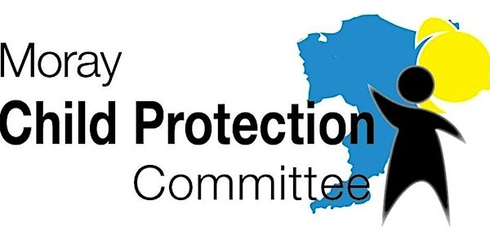

Version Number: | V1
Approved by: | Child Protection Committee | 20/06/2023
Effective from: | 01/08/2023
Date for Review: | December 2023
Owner: | Children and Families and Justice Social Work Policy Team
EIA and CRWIA | Considered | 24/05/2023
GDPR Compliant | Yes
FOI Compliant | Yes
Version Number | History of Amendments | Date
This guidance is available in different formats and languages on request. Please contact candfpolicy@moray.gov.uk


Contents
1. Introduction and context 3
2. Scope 4
3. Procedure 4
3.1. Initial resolution 4
3.2. Stage 1: escalation to first line management 5
3.3. Stage 2: escalation to second line management 6
3.4. Stage 3: escalation to third line management 7
3.5. Stage 4: escalation to Head of Service or Chief Officers 8
4. Quality assurance 10
5. Implementation plan 10
Appendix 1 - Flowchart 12
Appendix 2 – Escalation record template 13
Appendix 3 – Line management across the partner agencies 16

Introduction and context

This document outlines the procedures relating to multiagency case escalation, the need for which was indicated by local Learning Reviews. Whilst there is clear evidence of good working relationships between partners in Moray, occasionally, differences across practitioners may arise which require timely resolution so as not to delay decision making and keep children safe. In particular, there may be occasions where one professional believes that other professionals’ (lack of) decisions and/or actions do not contribute to the safeguarding and supporting of a child or young person. Furthermore, there may also be times when there is an escalation of risks and the mitigation of these is unsuccessful for a variety of reasons. In such circumstances, it may be that oversight is needed to address concerns and resolve disagreements.
Arising from this context, the aim of the procedure is to provide clarity to practitioners within the partnership in terms of the ways of seeking support and oversight from senior staff when a case is complex and one or more professionals have identified an issue, such as:
- Practitioners involved in the case cannot reach consensus about case management and decisions, individual processes, procedures and practice: for example, the risk around the child/family are believed to be increasing and there is no consensus and/or success around the management of the increased risks; there appear to be safety concerns for staff to work with the family/child and there is no consensus and/or success around the management of these concerns;
- One professional/agency believes that progress towards improved outcomes for a child is not achieved: for example, agreed actions are not progressed in a timely fashion; the agreed actions appear to be unhelpful but their revision is obstructed; the appropriateness and suitability of various interventions is disputed amongst professionals; the outcomes of assessments and conclusions are disputed amongst professionals
This procedure applies to cases of non-emergency, but escalating risk. This procedure can be used where the risk the child faces or poses appears to be increasing (but there is no emergency) and professionals have discussed the concern in existing fora (e.g., LAC Review, Core group meeting, Review Child Protection Planning Meeting). Where there is an emergency escalation in the case, the Lead Professional and/or the Police should be notified and ‘standard’ Child Protection Procedures apply.
This document corresponds with but differs from Moray’s Multiagency Reflective Case Discussion Procedure in two major ways. Firstly, a Reflective Case Discussion Meeting is not a decision-making forum, whereas it is likely that decisions for the case will be made as part of or result of their escalation. Secondly, this procedure is appropriate when professionals have a clear understanding of issues or concerns around the case; as opposed to this, invoking the Multiagency Reflective Case Discussion procedure may be appropriate when a case is complex, does not seem to be progressing for unknown reasons and professionals wish to come together to support each other in understanding the case.
The procedure relates specifically to multi agency disagreement and does not cover disagreement within single agencies which are usually addressed by single-agency escalation policies or procedures. Likewise, this procedure does not apply to cases where there may be concerns about the behaviour or conduct of another professional that may impact on child’s safety or wellbeing. In such cases, individual agency processes are applicable.

Scope
This procedure applies to all staff involved in multiagency child planning and protection processes and is expected to be employed from 01/08/2023. Any additions or potential exemptions to the procedure will be considered on an exceptional basis by the approving committee/board.
All staff/groups with responsibilities around multiagency child protection should be aware of and ensure that they comply with the procedure. The Children and Families and Justice Social Work Policy Team, alongside the Child Protection Guidance Implementation Group, will communicate information on the procedure to all necessary staff/groups and ensure that it is accessible on appropriate websites. All partner agencies are responsible for ensuring that corresponding procedures/policies are developed and employed in their respective agencies.

Procedure
Subsequent sections outline the step-by step process of escalation as well as the responsibilities of professionals within it.
It is important to note here that the escalation process below is preceded by the exploration of any issues within single-agency supervision. The escalation process consists of 6 stages (Appendix 1) and it is expected that ‘Initial resolution’ and ‘Stage 1’ of this procedure are used routinely and professionals should always aim to avoid escalation where possible. Escalation to stages 2 to 5 is for exceptional circumstances. Concerns should not be escalated multiple times.
The procedure below makes reference to the Escalation record template (Appendix 2). This template serves as a tool for recording the entirety escalation process (regardless of the stage it reaches) from Stage 1 onwards. It can also be used to facilitate discussion within single agencies prior to the meeting with counterparts being sought. It is the responsibility of the escalating agency to complete this record and disseminate it to the appropriate audience (decided during discussions).
In order to accommodate the organisational hierarchies of the partner agencies, the procedure refers to first, second, third and fourth line management. Appendix 3 outlines the roles that fall into these classes across Social Work, Health, Education, Police and Early Years.

Initial resolution
When situations outlined in section 1 arise, the practitioners involved must exercise professional judgement and fulfil their duty of care to the children and families they work with. Specifically, we have a legal responsibility to ensure that children’s welfare is the paramount consideration over all other matters. This means that professionals, whilst remaining respectful, may challenge each other and raise any concerns they may have due to the importance of the safety and wellbeing of the child.
In the first instance, the concerned professional should outline and evidence their concerns clearly and convey them to the other professional(s) via initial discussion. Depending on the circumstances and nature of the concern, this may happen in a one-to-one or group setting. The latter should be facilitated by the Lead Professional.
To aid such a discussion and the resolution of the concern, the practitioners involved should:
- Remain respectful, open-minded and professional
- If appropriate, clarify and reiterate individual professionals’ roles, remit and responsibilities
- Clarify and reiterate the partner agencies’ perspectives around the case
- Clarify and evidence the concern
- Attempt to find timely, effective and shared resolution via dialogue
There are two possible outcomes:
- If the outcome resolves the issue and has implications for the management of the case, it needs to be discussed with the team around the child and the family at the next available meeting with a view to amend the Child’s plan. In urgent cases, an extraordinary meeting may need to be arranged. Actions agreed need to be followed up, as per standard practice.
- If the issue cannot be resolved during the discussion, a summary of the discussion as well as the concerned professional’s position and intention to escalate the issue needs to be noted in the Escalation recording tool (Appendix 2), sent within 5 working days to the team around the child, where appropriate. The professionals constituting the team can update their respective databases/records based on the Escalation record (Appendix 2) produced by the concerned professionals.

Stage 1: escalation to first line management
When a resolution cannot be reached in the initial stage, the concerned practitioner should escalate the concern to their own immediate line manager without delay.
Whilst it is likely that the issue has been discussed during supervision, the concerned professional may wish to discuss the following to their supervisor:
- Outline and evidence their concerns/ reason for the issue
- Outline and evidence their attempt to resolve the issue
- Ask for the line managers’ thoughts around the concern and the disagreement
- Ask for input around next steps
- Keep a record of the discussion and any actions agreed (using the template in Appendix 2)
The approached line manager should:
- Examine and confirm the validity of the concern and the actions taken to resolve it
- Ensure that attempts at resolution at practitioner level have been exhausted
- Where appropriate, contact their equivalent at partner agencies as soon as possible (e.g., via telephone)
- During the discussion, clarify and evidence the concern as well as steps taken to resolve it
- During the discussion, seek a resolution at first line manager level
The discussion can have two outcomes:
- Resolution, in which case the agreed outcomes may have implications to the case, and as such, both need to be discussed with the family at the next meeting (which may be an extraordinary one) and recorded in the appropriate single agency databases/records. Agreed actions need to be followed up.
- Continuation of the disagreement and escalation, in which case the concerned professional’s line manager signals intention to escalate the issue further. This can be done via completion of the Escalation record (Appendix 2) which should be distributed within 5 working days of the discussion to the team around the child, as appropriate (decided by the attendees).

Stage 2: escalation to second line management
In exceptional circumstances, when a resolution at Stage 1 cannot be found, the concerned practitioner’s first line manager (e.g., Senior Social Worker; Nursery Manager) should escalate the concern to their own line manager (e.g., Area/Team manager; Continuous Improvement Officer) without delay.
At the meeting, the concerned professional’s first line manager should:
- Outline and evidence the concerns/ reason for the issue
- Outline and evidence attempts to resolve the issue
- Ask for the second line manager’s thoughts around the concern and the disagreement
- Ask for input around next steps
- Keep a note of the discussion and any actions agreed (Appendix 2)
The approached team/second line manager should:
- Examine and confirm the validity of the concern and the actions taken to resolve it
- Ensure that attempts at resolution at practitioner and first line manager levels have been exhausted
- Arrange a meeting with their equivalent at partner agency as soon as possible
At the meeting, minuted by the agency calling the meeting, the concerned second line manager should:
- clarify and evidence the concern as well as steps taken to resolve it
- request that the actions, inactions or decision-making dispute or disagreement be reviewed and seek a resolution at Stage 2
A meeting between the second line managers (also attended by a minute taker of the escalating agency) can have two outcomes:
- Resolution, in which case the escalating agency’s minute taker, within 5 working days emails the completed Escalation record (Appendix 2) to the team around the child, any relevant supervisors, and the approached line manager(s), as appropriate (decided by the attendees). The Escalation record summarises the discussion and any outcomes. These outcomes may have implications to the case and are recorded in the appropriate single agency databases/records. Agreed actions are to be followed up.
- Continuation of the disagreement and escalation, in which case the escalating agency’s minute taker, within 5 working days, sends the Record (Appendix 2) to the team around the child, any relevant supervisors and the approached line manager, as appropriate (decided by the attendees). The Record (Appendix 2) summarises the discussion, the negative outcome and the intention of the second line manager to escalate the issue. The professionals constituting the team around the child should update their databases/records accordingly.
The Record (Appendix 2) should be shared with candfpolicy@moray.gov.uk for quality assurance purposes.

Stage 3: escalation to third line management
In exceptional circumstances, when a resolution at Stage 2 cannot be found, the concerned practitioner’s second line manager (e.g., Area/Team manager; Continuous Improvement Officer) should escalate the issue to their own line manager (e.g., Service manager; Early Years Service Manager) in partner agencies without delay.
At the meeting, the concerned professional’s second line manager should use the completed Record (Appendix 2) to:
- Outline and evidence the concerns/ reason for the issue
- Outline and evidence attempts to resolve the issue
- Ask for the service managers’ thoughts around the concern and the disagreement
- Ask for input around next steps
- Keep a record of the discussion and any actions agreed
The concerned service/third line manager should:
- Examine and confirm the validity of the concern and the actions taken to resolve it
- Ensure that attempts at resolution at pervious levels have been exhausted
- Arrange a meeting with their equivalent(s) at partner agencies within 5 working days
- At the meeting, clarify and evidence the concern as well as steps taken to resolve it
- At the meeting, ask that the actions, inactions or decision-making dispute or disagreement be reviewed and seek a resolution at third line manager level
A meeting between the service managers (also attended by a minute taker provided by the concerned agency) can have two outcomes:
- Resolution, in which case the concerned agency’s minute taker, within 5 working days emails the completed Record (Appendix 2) to the team around the child, any relevant supervisors, managers and the approached third line manager(s), as appropriate (decided at the meeting). The Record (Appendix 2) summarises the discussion and any outcomes. These outcomes may have implications to the case and are recorded in the appropriate single agency databases/records. Agreed actions need to be followed up.
- Continuation of the disagreement and escalation, in which case the concerned agency’s minute taker, within 5 working days, sends the completed Record (Appendix 2) to the team around the child, any relevant supervisors, and the approached line manager, as appropriate (decided by the attendees). The Record (Appendix 2) summarises the discussion, the negative outcome and the intention of the concerned professional’s third line manager to escalate the issue. The professionals constituting the team around the child need to update their databases/records accordingly.
The notes of the meeting should be shared with candfpolicy@moray.gov.uk for quality assurance purposes.

Stage 4: escalation to Head of Service
In exceptional circumstances, when a resolution within the service/third line managers’ forum cannot be found, the concerned practitioner’s third line manager (e.g., Service manager, Early Years Service Manager) should escalate the concern to their Head of Service without delay.
At the meeting, the concerned professional’s third line manager should:
- Outline and evidence the concerns/reason for the issue
- Outline and evidence attempts to resolve the issue
- Ask for the Head of Service’s thoughts around the concern/disagreement
- Ask for input around next steps
- Keep a record of the discussion and any actions agreed
The approached Head of Service needs to:
- Examine and confirm the validity of the concern and the actions taken to resolve it
- Ensure that attempts at resolution at previous stages levels have been exhausted
- Arrange a meeting with their equivalent(s) at partner agencies as soon as possible
- At the meeting, clarify and evidence the concern as well as steps taken to resolve it
- At the meeting, ask that the actions, inactions or decision-making dispute or disagreement be reviewed and seek a resolution at Stage 4
A meeting between the Heads of Services (also attended by a minute taker provided by the escalating agency) can have two outcomes:
- Resolution, in which case the concerned agency’s minute taker, within 5 working days, emails the completed Record (Appendix 2) to the team around the child, any relevant supervisors, managers and the approached first/second/third line manager(s), as appropriate (decided at the meeting). The Record (Appendix 2) summarises the discussion and any outcomes. These outcomes may have implications to the case and are recorded in the appropriate single agency databases/records. Agreed actions need to be followed up.
- Continuation of the disagreement and escalation, in which case the concerned agency’s minute taker, within 5 working days, sends the completed Record (Appendix 2) to the team around the child, any relevant supervisors, and the approached line manager, as appropriate (decided by the attendees). The Record (Appendix 2) summarises the discussion, the negative outcome and the intention of the concerned professional’s Head of Service to escalate the issue. The professionals constituting the team around the child need to update their databases/records accordingly.
The notes of the meeting should be shared with candfpolicy@moray.gov.uk for quality assurance purposes.

Stage 5: Ultimate decision-making
Whilst it is hoped that the Head of Services can come to joint resolution, ultimately, the Chief Social Work Officer (CSWO) has the responsibility for the final decision. According to The Protecting children and young people: Child Protection Committee and Chief Officer responsibilities, the role of the CSWO includes advising and challenging all partners on child protection matters, including (but not limited to) values and standards, practice and managerial decision-making, leadership, and accountability.
The escalating agency’s Head of Service needs to approach the Chief Social Work Officer for a meeting without delay. At the meeting, the concerned professional’s Head of Service, using the Record (Appendix 2) should:
- Outline and evidence the concerns/reason for the issue
- Outline and evidence attempts to resolve the issue
- Ask for the CSWO’s thoughts around the concern/disagreement
- Ask for input around next steps
- Keep a record of the discussion and any actions agreed
The CSWO needs to:
- Examine and confirm the validity of the concern and the actions taken to resolve it
- Ensure that attempts at resolution at previous stages levels have been exhausted
- Arrange a meeting with the involved Heads of Services as soon as possible
- At the meeting, make a decision and outline the rationale
The minute taker (a member of the agency calling the meeting), distributes the completed Record (Appendix 2) of the CSWO’s meeting to the appropriate managers and practitioners within 5 working days, as appropriate (decided at the meeting). The frontline professionals should action, adhere to, and record in individual agency databases/records the decisions made. Agreed actions must be completed in a timely fashion.
The completed Record (Appendix 2) should be shared with candfpolicy@moray.gov.uk for quality assurance purposes.

Quality assurance
It is imperative that the partner agencies are alert to learning and improvement opportunities, including in relation to the escalation process. Given the operational nature of the escalation process and Social Works ultimate responsibility in child protection matters, the quality assurance of this process is likely to be conducted within Social work’s quality assurance team.
Specifically, the quality assurance of this procedure is likely to include the development, maintenance and regular analysis of a databases/records detailing (amongst others):
- Summary of issue
- Reason for escalation
- Timeframes
- Stages reached
- Type of issue/concern
- Resolution
Any report should outline actions that should be taken both to reduce the need for escalation (by, for example, arranging training or developing procedures/policies) and to increase the effectiveness of the escalation process (by, for example, developing effective communication channels), as appropriate.

Implementation plan
1. Title of document | Multiagency escalation procedure
2. Owner of document | Children and Families and Justice Social Work Policy Team
3. What is it? (e.g., new policy, updated policy, guidance etc.) | New multiagency procedure
4. Where is it stored? | Intranets
5. What is the implementation date/timeframe? | August 2023
6. Dissemination methodology (e.g. Cascade through snr officers and individual services, team meeting approach, Locality approach, Launch event, Focus Groups, Event based approach, 7 min Briefings)
Social work:
- Cascade via email briefing
- Team meeting approach (Policy team)
Education:
- Cascade via email briefing
- Child Protection Coordinators’ Network

Health:
- Cascade via email briefing to workforce

Police:
- Dissemination to officers via email. Public Protection Unit will carry out face to face briefings. Across the wider division, line managers will be encouraged to do likewise with their staff.

7. Stakeholders (audience), their roles and responsibilities
The procedure provisions responsibilities to staff from frontline to senior management levels across the partner agencies. It is expected that they follow the procedures throughout.
8. Training Needs Assessment
Nature |  | Scope |  | Delivery Format |  | Resource
One-off |  | Single Agency |  | Self-led |  | Met within existing
Ongoing |  | Multi-agency |  | Facilitated |  | Resource required

Details

None needed
9. Impact: What would you expect to see as a consequence and where would you look for impact? (e.g. case file reading, recording processes, Focus groups of parents/carers and families, and staff)
Staff confidence in requesting oversight; improved management of high risk cases.

Appendix 1 – Flowchart
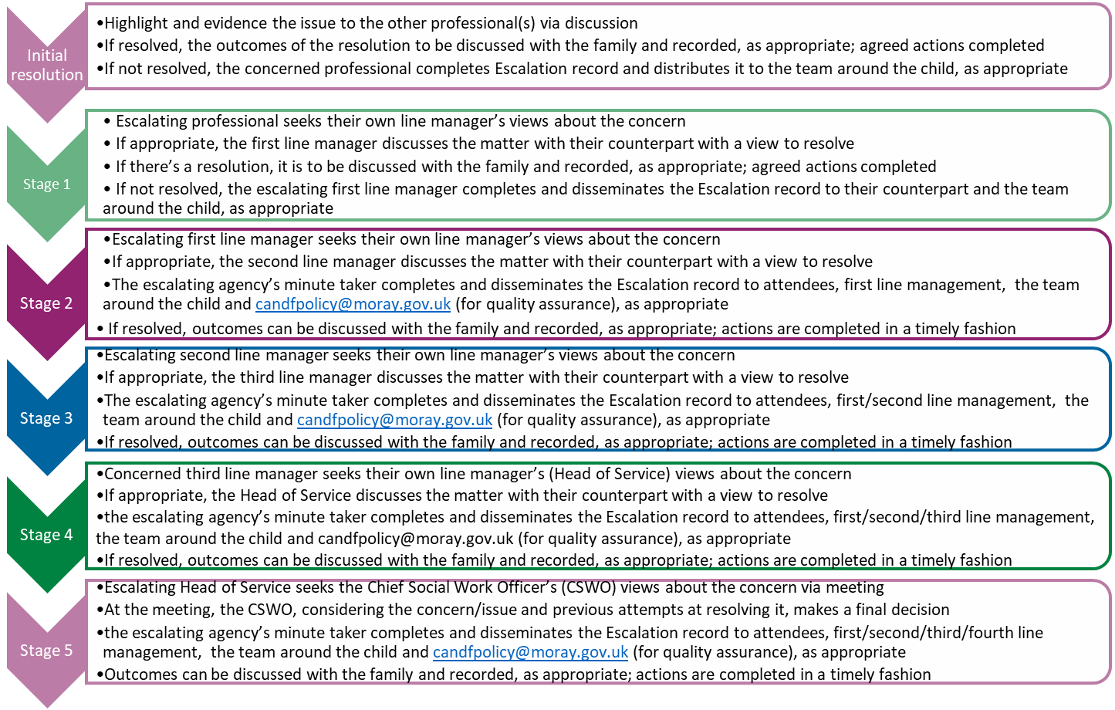

Appendix 2 – Escalation record template



Escalation
recording tool

Escalating agency:
Child’s name:
Reason for escalation (please tick)
☐ | Practitioners involved in the case cannot reach consensus about case management and decisions, individual processes, procedures and practice: for example, the risk around the child/family are believed to be increasing and there is no consensus and/or success around the management of the increased risks; there appear to be safety concerns for staff to work with the family/child and there is no consensus and/or success around the management of these concerns
☐ | One professional/agency believes that progress towards improved outcomes for a child is not achieved: for example, agreed actions are not progressed in a timely fashion; the agreed actions appear to be unhelpful but their revision is obstructed; the appropriateness and suitability of various interventions is disputed amongst professionals; the outcomes of assessments and conclusions are disputed amongst professionals
Summary of issue/concern (background to the case and reason for escalation, views of the child and family)
Previous attempts at resolution at initial level
Stage 1/First line management: Outcome (please choose one from the dropdown and then expand below around rationale for decision and any actions agreed, attendees of the meeting, etc.) |  | Choose an item. | Date:
Stage 2/Second line management: Outcome (please choose one from the dropdown and then expand below around rationale for decision and any actions agreed, attendees of the meeting, etc.) |  | Choose an item. | Date:
Stage 3/Third line management: Outcome (please choose one from the dropdown and then expand below around rationale for decision and any actions agreed, attendees of the meeting, etc.) |  | Choose an item. | Date:
Stage 4/Fourth line management: Outcome (please choose one from the dropdown and then expand below around rationale for decision and any actions agreed, attendees of the meeting, etc.) |  | Choose an item. | Date:
Stage 5: Chief Social Work Officer decision (please outcome/decision and expand around rationale for decision and any actions agreed, attendees of the meeting, etc.) |  | Date:

Appendix 3 – Line management structure across the partner agencies

 | Social work | Health | Education | Police | Early years
Practitioner | Social Worker | Midwife/ Health visitor | Head teacher/Deputy Head Teacher/Principal Teacher Additional Support Needs/ Principal Teacher of Guidance | Police Constable / Police Sergeant Community Policing / Detective Constable | Early Years Practitioner/Senior Early Years Practitioner
First line management | Senior Social Worker | Team Leader | Head teacher/Deputy Head Teacher | Public Protection Unit / Concern Hub | Nursery Manager
Second line management | Team/Area Manager | Specialist Nurse for Child Protection | Quality Improvement Officer | Detective Sergeant Public Protection Unit / Concern Hub | Continuous Improvement Officer
Third line management | Service Manager | Service Manager | Quality Improvement Manager | Detective Inspector | Early Years Service Manager
Fourth line management | Head of Service Social Work | Head of Service Social Work | Head of Education/Education Chief Officer | Detective Chief Inspector | Head of Education/Education Chief Officer
Ultimate decision-making by Chief Social Work Officer

